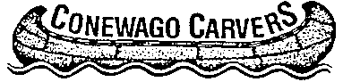
Show Committee Meeting
March 8, 2014; 4:30 pm

2014 Show

Theme
  - Show Name
  - Tables
  - Admission
  - Competition
  - Publicity
  - Sponsorships
  - Silent Auction
  - Ornament sale/Raffle
  - Door Prizes
  - Exhibitor Badge
  - Feature Artists
  - Signs
  - Banquet

- Next Meeting: May 18, 1 pm

