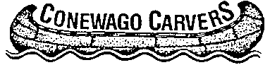
Show Committee Meeting
September 21, 2014; 1:00 pm

2014 Show

Theme
  - Tables
  - Admission
  - Competition
  - Publicity
  - Sponsorships
  - Silent Auction
  - Ornament Sale/Raffle
  - Door Prizes
  - Exhibitor Badge
  - Feature Artist
  - Signs
  - Banquet

- Next Meeting: October 19, 1 pm

